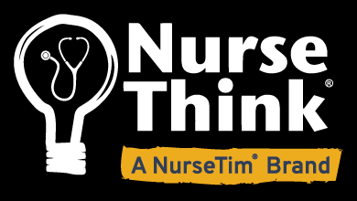

Criteria for the NurseThink $1,000 Scholarship 2023
This scholarship is being awarded by NurseThink to a Kentucky League for Nursing Member pursuing a graduate degree with the intent of teaching.

Criteria:
The minimum qualifications for the award are as follows: The applicants must have:
- current membership in the Kentucky League for Nursing and be a participant in the Annual Meeting of the KLN.
- an active, unrestricted Kentucky Nursing License.
- been accepted into an accredited graduate level program leading to a degree in Nursing or related field at either the masters or doctoral level.
- the intention of remaining in the Commonwealth of Kentucky to teach in an undergraduate or graduate level program of nursing.
- additional documents as noted on the application form.

Scholarships will be awarded during the Annual Business Meeting of the Kentucky League for Nursing on May 18, 2023.
Recipient must be present to receive award.

Return all required documentation before April 15, 2023 to:
kyleaguenursing@yahoo.com

The scholarship will be awarded to a qualified applicant regardless of age, sex, race, religion, or political affiliation.

Application for the NurseThink $1,000 Faculty Scholarship 2023
PLEASE PRINT OR TYPE
Name:
(First) (Last)
Address:
(Street) (City) (State) (Zip)
Telephone: Home/Cell ( ) Email:
Are you a current member of the Kentucky League for Nursing? Yes No
Do you hold a current KY nursing license? Yes No KY License #
Major/Degree Program/School:
Credit Hours completed: Date Degree Expected:
Current employment:
Please attach the following documents:
- One letter of recommendation.
- Curriculum vitae.
- Current transcript indicating registration for a graduate degree program or copy of letter of acceptance.
- Typed response to the following question.

Describe how you intend to promote professional practice in nursing education, both in theory and engagement in professional organizations.
Date: Applicant’s Signature:
Scholarships will be awarded during the Annual Business Meeting of the Kentucky League for Nursing on May 18, 2023.
Recipient must be present to receive award.
Return all required documentation before April 15, 2023 to: kyleaguenursing@yahoo.com

The scholarship will be awarded to a qualified applicant regardless of age, sex, race, religion, or political affiliation.

